**CROP RECOMMENDATION SYSTEM**

Aditi Jain, Akshay Singh, Vaibhav Chauhan

B. Tech

Department of Computer Science and Engineering

Inderprastha Engineering College, Sahibabad, Ghaziabad, India

Dr. Kumud Kundu

Professor

Dr. Tripti Sharma

Professor

Department of Computer Science and Engineering

Inderprastha Engineering College, Sahibabad, Ghaziabad, India

***Abstract*** - Farming, encompassing soil cultivation, crop production, and livestock management, plays a pivotal role in a nation's economic progress. With approximately 58 percent of the population relying on agriculture as their primary livelihood source, its significance cannot be overstated. Historically, farmers have predominantly employed conventional farming methods, which, while familiar, have often proven imprecise and time-consuming, hampering productivity. Precision farming, on the other hand, offers a solution by meticulously determining optimal practices for each stage of cultivation. This approach involves forecasting weather patterns, analysing soil characteristics, recommending suitable crops, and determining precise quantities of fertilizers and pesticides. Leveraging technologies such as IoT, data mining, analytics, and machine learning, precision farming streamlines data collection, system training, and result prediction, thereby reducing manual labour and enhancing productivity. Contemporary farmers grapple with numerous challenges, including crop failures due to erratic rainfall and soil infertility, exacerbated by environmental changes. The proposed research aims to address these challenges by facilitating crop selection. The proposed system leverages an ensemble of classifiers, including Naive Bayes and Random Forest, to provide comprehensive and accurate crop recommendations based on farm-specific parameters.

***Keyword*** – Precision Agriculture, Crop recommendation System (CRS), Machine Learning, Support Vector Machine (SVM), Decision Tree, Random Forest, Nitrogen-Phosphorus-Potassium (NPK), K-Nearest neighbour (KNN), Convolutional Neural Networks (CNN), Recurrent Neural Networks (RNN).

**I.INTRODUCTION**  
Agriculture, being the backbone of economies like India, plays a pivotal role in sustaining livelihoods and ensuring food security. However, the sector grapples with multifaceted challenges ranging from unpredictable weather patterns to resource constraints and market volatility. Amidst these challenges, precision farming emerges as a promising solution, offering tailored strategies to optimize farm management practices.

The significance of this research lies in its potential to revolutionize traditional farming practices by offering data-driven insights and recommendations tailored to the unique needs of individual farms. By empowering farmers with actionable information, the CRS aims to mitigate risks associated with crop selection, optimize resource utilization, and improve overall yield and profitability.

Furthermore, the adoption of precision farming techniques facilitated by the CRS holds promise for promoting sustainable agricultural practices. By enabling targeted inputs and reducing wastage, farmers can minimize environmental impact while maximizing output, contributing to long-term agricultural resilience and food security. The Crop Recommendation System for agriculture suggests crops for Indian states based on key input parameters, including Temperature, Rainfall, Humidity, Nitrogen, Potassium, and Phosphorus values. Utilizing classifier machine learning and deep learning algorithms, the recommender model is designed to provide crop recommendations based on relevant parameters. This technology-driven agricultural solution enhances farmers' crop yield by recommending suitable crops tailored to their land, considering geographic and climatic factors. The proposed ensemble model has proven effective in suggesting appropriate crops, with positive implications for guiding agricultural production and informing farmers about market rate changes. The paper emphasizes implementing a crop selection method to address agricultural challenges, contributing to India's economic growth by optimizing crop yield rates across different land conditions.

**II. LITERATURE SURVEY**

India is a country where a majority rely on agriculture as their occupation. The repeated cultivation of the same crops without considering soil conditions and the use of same fertilizers lead to reduced crop yields, soil acidification, and top-layer damage. To address these issues, we need to use automated means of predicting the best crops for cultivation for a particular area and region. By utilizing machine learning algorithms, we can help farmers in making informed decisions.

In addition to suggesting the most suitable crop for a specific piece of land, the paper provided information on the required content and quantity of fertilizers, as well as the necessary seeds for cultivation. Machine learning algorithms such as SVM were used for rainfall prediction and Decision Tree for crop prediction. The system further recommends the most suitable crop, provides information on required nutrients and seeds, and displays the market price and approximate yield for the recommended crop [1].

Precise Farming uses advanced technologies such as IOT, Data Mining, Data Analytics, Machine Learning to collect the data, train the systems and predict the results. With the help of technologies Precise farming helps to reduce manual labor and increase productivity. It guides an individual for smart farming.

Around 10 different classification algorithms to find the best model for future prediction. Hyperparameter tuning was applied to these algorithms provide more accuracy. The Random Forest model hyper tuned with Randomized CV was selected as the best model [2].

For most developing countries, agriculture is their primary source of revenue. Modern agriculture is a constantly growing approach for agricultural advances and farming techniques. It becomes challenging for the farmers to satisfy our planet's evolving requirements and the expectations of merchants, customers, etc. [3]. It compares various supervised learning algorithms like KNN, Decision Tree, and Random Forest. It uses Decision Tree and Random Forest Classifier and evaluates the model's performance under two criterions- Entropy and Gini Index. It concluded with Random Forest having the highest accuracy among the three.

Modern agriculture relies heavily on advanced technologies such as sensors, robots, and GPS, revolutionizing farming practices for increased profitability, efficiency, and sustainability. These technologies, including remote sensors and cameras, gather continuous data on soil health, plant conditions, and environmental factors, aiding farmers in making informed decisions. Integration of Arduino microcontrollers and machine learning algorithms like Naïve Bayes and Support Vector Machine further enhances data processing and decision-making accuracy, with a success rate exceeding 95%. This technology holds promise for both rural and urban areas, offering cost-effective and autonomous solutions for agricultural management in Sri Lanka [4].

The agricultural industry is a huge source of wealth for the country. However, when compared to other agricultural products, the yield per hectare is disappointing. There are numerous reasons why marginal farmers in India have a higher suicide rate. The work [5] connects Farmers through a smartphone app. GPS technology aid in user identification and location. The user specifies the area and type of soil in which they want to work, and machine learning algorithms enable the selection of the most profitable user-selected crop yield prediction or crop list. Support Vector Machine (SVM), Artificial Neural Network (ANN), Random Forest (RF), Multivariate Linear Network (MLN), and a combination of regression and KNN are used to estimate crop yields. The Random Forest produced the best results of the three. The rate of accuracy is 95%. Aside from that, the system recommends the best options available.

India is characterized by small farms. Over 75% of total land capitals within the country are less than 5 acres. Most crops are rain nourished, with just about 45% of the land irrigated. As per some estimations, about 55% of total population of India depends on farming. In the US, because of heavy mechanization of agriculture, it is about 5%. India is one of the biggest producers of agricultural products and still has very less farm productivity. Productivity needs to be increased so that farmers can get more pay from the same piece of land with less labour. Precision agriculture provides a way to do it. Ensembling is one such approach. The ensemble technique employed is Majority Voting, with base learners including Support Vector Machine, Naïve Bayes, Multi-layer Perceptron, and Random Forest [6].

**III. METHODOLOGY**

The proposed system is a Web Application powered through the Django Framework. It uses the crop recommendation dataset from the Kaggle Website. The dataset contains 8 parameters like rainfall, temperature, humidity, NPK values, pH and the label. Firstly, the necessary libraries such as Sci-kit learn, Keras, Tensorflow, NumPy, Pandas, Pickle, Seaborn, Matplotlib were imported. The dataset contains 22 varieties of crops with 2200 instances. Every crop has exactly 100 instances present in the dataset. The dataset does not contain any missing or null values. All the fields were in numerical values except the label field. So, label encoding was applied to convert it into numbers and then back into text at the time of recommendation.

Notably, this paper distinguishes itself by omitting pH from predictive factors, as its inclusion was found to have minimal impact through data visualization techniques.

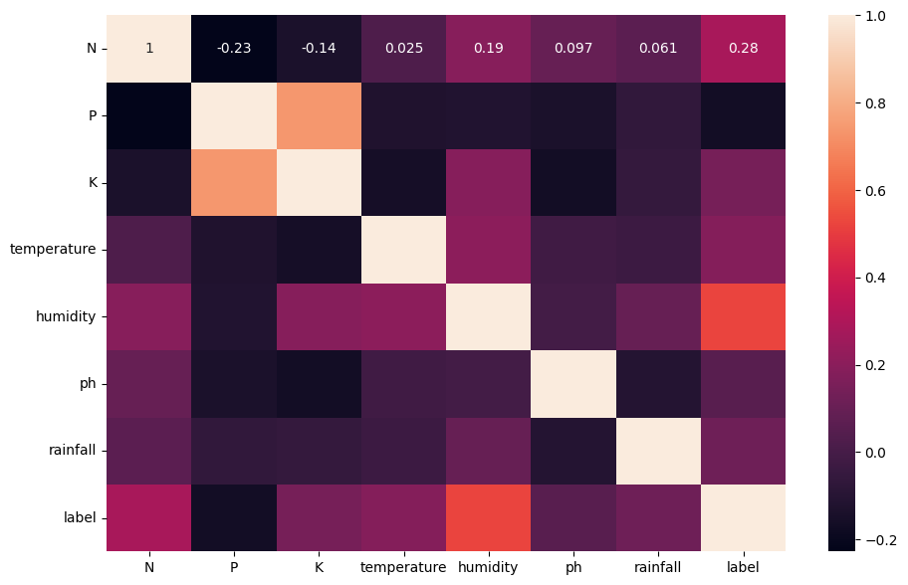

After removing the pH parameter from the dataset. The machine learning models such as Logistic Regression, Naïve Bayes, Support Vector Machines were imported. From Keras, layers such as Conv1D, MaxPooling1D, Flatten, Dense, LSTM etc were imported.

Around ten machine learning algorithms were evaluated for crop recommendation, including Logistic Regression, K-Nearest Neighbours, Decision Tree, Random Forest, Naive Bayes, Support Vector Machine, Bagging, AdaBoost, Gradient Boosting, and various Deep learning models like Feed Forward Networks, CNN, RNN, and Gated Recurrent Networks (GRN) were also used.

**Comparison b/w different algorithms used**

|  |  |  |
| --- | --- | --- |
| S. No. | Algorithm Used | Accuracy |
| 1. | Logistic Regression | 94% |
| 2. | K-Nearest-Neighbours | 97% |
| 3. | Decision Tree | 98% |
| 4. | Random Forest | 99% |
| 5. | Naïve Bayes | 99% |
| 6. | Support Vector Machine | 95% |
| 7. | Bagging | 98% |
| 8. | Ada Boost | 14% |
| 9. | Gradient Boosting | 98% |
| 10. | Cat Boost | 98% |
| 11. | CNN | 95% |
| 12. | Feed Forward Network | 95% |
| 13. | RNN | 95% |
| 14. | Gated Recurrent Network | 94% |

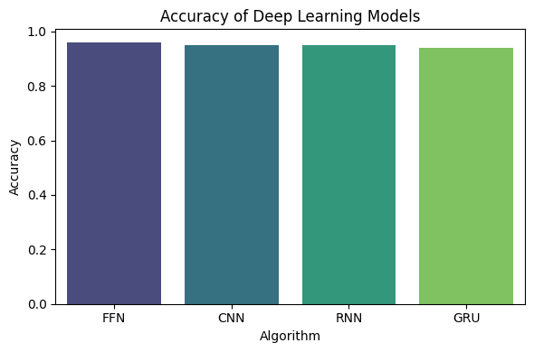

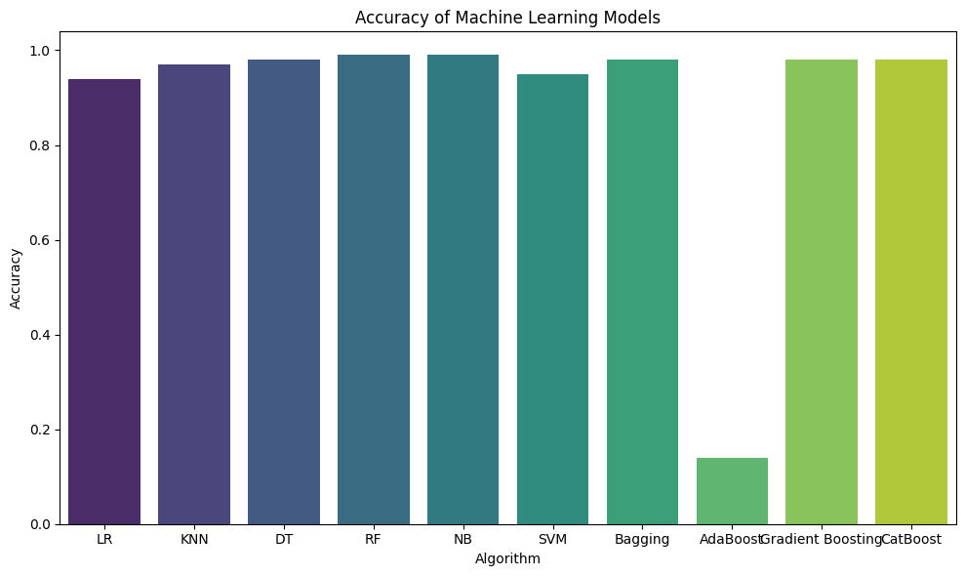

Naïve Bayes and Random Forest achieved an accuracy of higher than 99%. So, they were selected as the base learners for the proposed ensemble model.

The proposed system leverages an ensemble of classifiers, including Naive Bayes and Random Forest, to provide comprehensive and accurate crop recommendations based on farm-specific parameters.

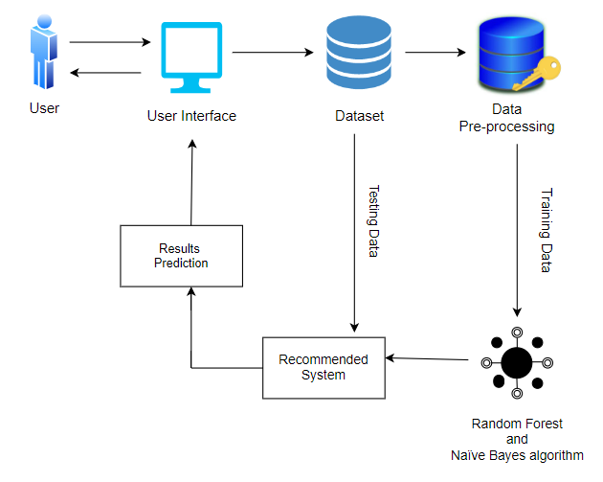

This innovation contributes significantly to India's economic landscape by optimizing crop production yields across diverse land conditions. The system employs a judicious combination of ensemble classifiers, featuring Naïve Bayes and Random Forest classifier, ensuring the precision of predictions. Furthermore, a sophisticated ranking technique is implemented to refine decision-making processes.

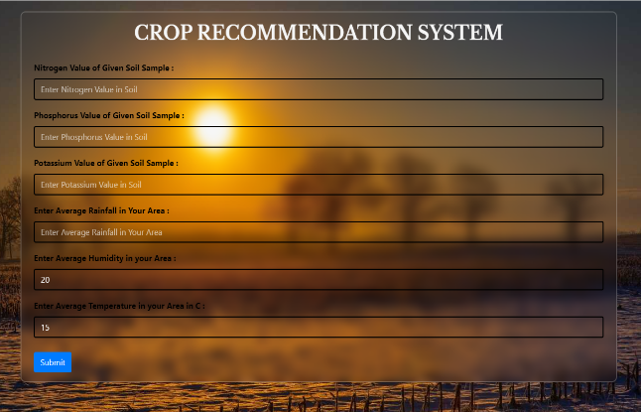

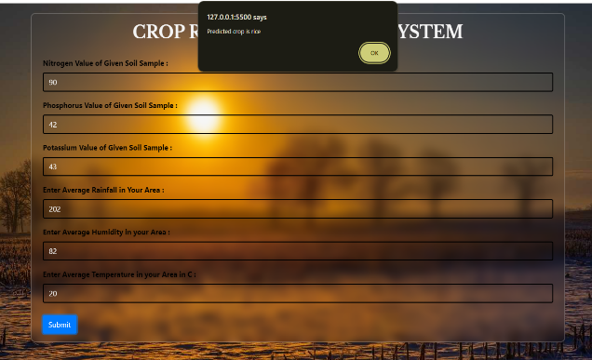

**V. RESULTS**

The proposed work presents a web application that requires least technical knowledge to operate so that farmers can easily use it to get the best suitable crop by entering values of NPK and rainfall. Since the system automatically fetches the humidity and temperature parameters based on the user's geographical location, leveraging JavaScript geolocation API and Open Weather Map API. When the user clicks on the submit button, they get the best recommended crop as per the values entered as an alert on the webpage.

The proposed work uses an ensemble of Naïve Bayes and Random Forest by employing the voting classifier strategy. The proposed work achieved an accuracy of 99.54%.

**VI. CONCLUSION AND FUTURE SCOPE**

The Crop Recommendation System (CRS) presented in this research offers a comprehensive solution to the challenges faced by farmers in crop selection. By leveraging an ensemble of classifiers such as Naive Bayes and Random Forest, the CRS provides personalized recommendations based on farm-specific conditions. The integration of machine learning and deep learning algorithms ensures accurate predictions, enabling farmers to make informed decisions that maximize productivity and profitability. Additionally, the web application interface enhances accessibility, allowing farmers to easily input their environmental conditions and receive timely recommendations. Through its holistic approach, the CRS demonstrates potential in revolutionizing agricultural practices and addressing the pressing need for sustainable and efficient crop management strategies.

The scope of the Crop Recommendation System extends beyond its current implementation, offering opportunities for further development and integration with emerging technologies. Future enhancements may include refining the prediction models by incorporating additional data sources such as satellite imagery and drone technology to provide more accurate and real-time insights. Moreover, expanding the web application's features to include educational resources, market analysis, and weather forecasts can empower farmers with a comprehensive toolkit for decision-making. Collaborations with agricultural extension services and government agencies can facilitate widespread adoption of the CRS, fostering a culture of data-driven farming practices and contributing to the advancement of agricultural sustainability on a broader scale. Ultimately, the CRS holds promise as a versatile and scalable solution to optimize crop selection and enhance overall farm productivity in diverse agricultural landscapes.

**VII. REFERENCES**

[1] Mahendra N, Dhanush Vishwakarma, Nischitha K, Ashwini, Manjuraju M. R, 2020, Crop Prediction using Machine Learning Approaches, INTERNATIONAL JOURNAL OF ENGINEERING RESEARCH & TECHNOLOGY (IJERT) Volume 09, Issue 08 (August 2020)

[2] Senthil Kumar Swami Durai, Mary Divya Shamili, Smart farming using Machine Learning and Deep Learning techniques, Decision Analytics Journal, Volume 3, 2022, 100041, ISSN 2772-6622, https://doi.org/10.1016/j.dajour.2022.100041

[3] Madhuri Shripathi Rao et al 2022 J. Phys.: Conf. Ser. **2161** 012033 “Crop Prediction using Machine Learning”

[4] Bandara, P.; Weerasooriya, T.; T.H., R.; Nanayakkara, W.; M.A.C, D.; M.G.P, P. Crop Recommendation System. Int. J. Comput. Appl. 2020, 175, 22–25, https://doi.org/10.5120/ijca2020920723.

[5] R. Jadhav and D. P. Bhaladhare, "A Machine Learning Based Crop Recommendation System: A Survey," Journal of Algebraic Statistics, vol. 13, no. 1, pp. 426–430, May 2022.

[6] Rajak, Rohit Kumar, Ankit Pawar, Mitalee Pendke, Pooja Shinde, Suresh Rathod, and Avinash Devare. "Crop recommendation system to maximize crop yield using machine learning technique." International Research Journal of Engineering and Technology 4, no. 12 (2017): 950-953.